**LEARNING EXPERIENCE / ASSESSMENT TASK**

|  |  |  |  |  |  |  |  |
| --- | --- | --- | --- | --- | --- | --- | --- |
| **Stage/Year:** | *Year 6, Stage 3* | **Unit Title:** | *Face the Unusual* | | **Duration:** | | *6 weeks* |
| **Rationale:** | This unit of work was developed to enrich students with the forms and materials associated with portraiture, and build on their experiences as an artist and critic. Ss will have the opportunity to explore Pablo Picasso and his artworks in order to identify ‘how he works and how he develops creative and innovative ideas’ to generate meaning. Students will make connections to the ways in which the subject matter of ‘people’ is represented in artworks, and use these works as inspiration for art-making (Board of Studies, 2006). | | | | | | |
| **Key Ideas:** | Ss will explore symbolism, cubism, surrealism, portraiture and emotions that reflect Picasso’s artworks (The Art Story Foundation, 2014). | | | | | | |
| **Conceptual Framework:** | Artist: The lessons will be centred on Pablo Picasso, however Ss will also have the opportunity to explore the inspiring artist, Paul Cezanne.  World: This unit explores the subject matter of ‘people,’ focusing on portraiture and emotions, which enables Ss to identify how this subject matter is represented in Picasso’s work, and also, to discover how Paul Cezanne inspired Picasso’s work.  Audience: Ss will review who Picasso created his artworks for, and will also act as critics to develop different meanings and feelings towards his portraiture.  Artwork: Ss will investigate the forms, techniques and materials used in Picasso’s artworks. | | | | | | |
| **Key Artists/Artworks:** | * Pablo Picasso (main artist) * Paul Cezanne (Inspired artist) | | | | | | |
| **Subject Matter:** | *People* | | | **Unit Focus:** | | *Portraiture and Emotions* | |
| **MAKING** | | | | **APPRECIATING** | | | |
| **Visual Arts Outcomes:** Makes artworks for different audiences assembling materials in a variety of ways (**VAS3.2**).  **KLA Links:**  Science (**ST2-5WT**)  PDHPE (**INS3.3, COS3.3**) [See Appendix 1] | | | | **Visual Arts Outcomes:** Communicates about the ways in which subject matter is represented in artworks (**VAS3.4**).  **KLA Links:**  English (**EN3-6B, EN2-1A, EN2-2A**)  PDHPE (**INS3.3, COS3.3**) [See Appendix 1] | | | |
| **Form:** painting and sculpting  **Techniques:** cubism, symbolism, surrealism  **Materials:** paint, paper mache | | | | **Art Historical:** Ss have the opportunity to investigate the history of the artist by looking at, reading about, talking about and writing about Picasso and his artworks.  **Art Critical:** Throughout the unit of work, Ss will act as critics to identify and interpret the subject matter, the techniques and the meanings behind Picasso’s work (REFERENCE). | | | |
| **Lesson Development:** | | | | | | | |
|  | | | | *1a As a whole-class, Ss will be introduced to three artworks by Picasso on the Interactive Whiteboard (IWB) and are required to explore what techniques, forms and materials they think are being used, and the subject matter that they believe is being portrayed. Questions to ask the Ss could include: What can you see? What might this artwork mean? How do you think it was created? Why do you think this approach was used? By enabling Ss to explore artworks without a ‘clouded’ mind, Ss can solely develop meaning from the work and discuss the artist’s intentions and use of techniques in selected works (Board of Studies, 2006).*  *In groups of 5, each group will focus on ONE of the following: who the artist is, what the artist does, how the artist produces artworks, who the artist creates artworks for, and why the artist creates artworks. Using the puzzle effect, Ss will divide into different table groups, and act as an expert in the field to educate their peers on their focus topic. Ss document their work as a group using a conceptual framework template (Ss use the iPad and printed resources to assist Ss in their learning).*  *Once information has been collected, Ss will reflect back on the original artworks they investigated, and re-assemble their interpretations of the work.* | | | |
| *2b In pairs, Ss will draw a basic sketch of each other using a pencil lightly. Ss are then required to re-adapt the sketch to incorporate specific forms, materials and techniques as applied by Picasso. The T will provide Ss with a list of simple instructions to guide Ss through their art making process. Steps to include could be: ‘change the nose into a cubist nose’, and ‘make the eyes look more surreal.’* | | | | *2a Students will be introduced to the specific forms, materials and techniques used in Picasso’s work through listening to the T descriptions and explanations. Key ideas that will be explored include cubism, symbolism and surrealism. After the T has demonstrated a clear insight into these words, Ss will then complete a fun whole-class ‘quiz’ on the IWB, where Ss are required to answer a range of questions involving: multiple choice, responding to artworks and representing information through drawing and body movements. This enables Ss to identify and represent the properties of different forms, materials and techniques in artworks and explain how these are ‘employed in the representation of subject matter’ (Board of Studies, 2006).* | | | |
| *3b In pairs, one Ss is blindfolded whilst the other Ss is drawing a basic picture with the focus on ‘body’ and incorporating cubism, surrealism, and symbolism. Once the Ss has completed his/her drawing, the second Ss can then remove his/her blindfold whilst their peer explains to the Ss through appropriate language what needs to be drawn, without displaying their work. For example, ‘draw a cubist hand, the size of a fist, on the left of the paper’. This activity enables Ss to examine a range of concepts and their relationships to selected forms (Board of Studies, 2006). It also provides students with the opportunity to actively produce works in oral form (Fordham, 2014).* | | | | *3a Ss will listen to a recording of the teacher, where she describes the techniques learnt in the previous lesson. Ss are encouraged to guess what technique the T is describing.*  *c. Once both Ss have played the role of the artist and the instructor, Ss are then required to write a reflection in their logbooks about their experience, and how the properties of form and techniques used can represent different meanings of ‘people’ (Board of Studies, 2014).* | | | |
| *4a With a partner, Ss will complete a continuous line drawing as a portrait of their peer. Ss are required to use a range of coloured pencils to colour their work, and are then required to cut their paper into approximately 5-6 pieces. Ss then rearrange these pieces and paste them on a different background.* | | | | *4b Once Ss have completed their artwork; they are required to write a description about one of Picasso’s works (The Weeping Woman, 1937 or The Seated Woman, 1937), making sure that they include relevant and appropriate terminology. In this, Ss need to describe the forms and techniques in the artwork, and explain how they reflect the subject matter of ‘people’ (Board of Studies, 2006).* | | | |
| *5b By discovering that Cezanne and Picasso both wanted to indulge the sensations of the eye using large brush strokes and sensational colour, Ss can begin to experiment with these aspects (Board of Studies, 2006). In this activity, the T will revisit the primary colours on the colour wheel, and model how to create cubism through large brush strokes. Ss then individually divide their paper into ten sections and experiment with the colour using large brush strokes. As Ss manipulate the primary colours, they are encouraged to consider the emotions that these colours might represent and label the emotion above the colour. By enabling Ss to distinguish feelings through colour, Ss can identify the conditions and requirements of artworks that are made for certain purposes, and develop an awareness of how this might affect how they approach their own art making (Board of Studies, 2006).* | | | | *5a In groups of three, Ss will use a Venn diagram to distinguish the similarities and differences between Picasso’s and Cezanne’s work. Through this exploration, Ss need to discover the who, what, how, who and why of Cezanne in order to compare and contrast his work to Picasso’s. By enabling Ss to explore Cezanne, Ss can consider a range of artworks and the subject matter associated with them, and also develop an understanding on how Cezanne inspired Picasso’s work (Board of Studies, 2006).* | | | |
| *6a Prior to the lesson, Ss will take a picture of themselves on the iPad using a distorted effect.*  *Using a printed copy of these images, Ss will complete a continuous line drawing to copy the picture onto an A3 sheet of art paper. Using the techniques of Picasso, Ss need to paint their work to experiment with the expressive use of colour and apply what they have learnt from previous lessons (Board of Studies, 2006).*  *Students then amplify the eyes, nose and mouth of the artwork using paper Mache, and attach it to the same features on the artwork in order to explore with the qualities and effects of sculpture (Board of Studies, 2006).* | | | |  | | | |
| **Assessment:** | | | | | | | |
| Ss will act as an artist to create a portrait artwork. Ss will:   * Take a picture of themselves using the ‘nose twirl’ effect on the iPad * Use the distorted image to view and copy onto an A3 art paper * Make sure that the portrait is larger than 25cm x 15cm * Apply painting to the artwork that reflects their emotions * Use of at least two techniques by Picasso * Use paper mache to sculpt the eyes nose and mouth to create a 3D effect [See Appendix 3] | | | | Ss will act as a critic to write a structured description based on one of Picasso’s artworks: ‘The Weeping Woman’ (1937) or ‘The Seated Woman’ (1937). Ss need to include:   * The artwork that they have chosen * The forms and techniques evident in the artwork and how they represent the subject matter * A description of how the artwork makes them feel * Appropriate language features and structure of a description [See Appendix 2] | | | |
| **Source Material:** | | | | | | | |
| *Paint*  *Paintbrushes*  *Glue*  *VAPD*  *Scissors*  *Newspaper*  *Water*  *Tissue paper*  *Led Pencils*  *Coloured pencils* | | | | *IWB*  *Log books*  *IPads*  *Book/printed resources*  *Venn diagram worksheets* | | | |

**Appendix 1**

**English**

**EN2- 1A** communicates in a range of informal and formal contexts by adopting a range of roles in group, classroom, school and community contexts

**EN2- 2A** plans, composes and reviews a range of texts that are more demanding in terms of topic, audience and language

**EN3-6B** - uses knowledge of sentence structure, grammar, punctuation and vocabulary to respond to and compose clear and cohesive texts in different media and technologies

**Science**

**St2-5WT** applies a design process and uses a range of tools, equipment, materials and techniques to produce solutions that address specific design criteria

**PDHPE**

**INS3.3** Acts in ways that enhance the contribution of self and others in a range of cooperative situations.

**COS3.3** Communicates confidently in a variety of situations.

**Appendix 2**

|  |  |  |  |  |  |
| --- | --- | --- | --- | --- | --- |
|  | **Art Appreciation Assessment Criteria** | | | | |
|  |  |  |  |  |  |
| **Structure and language features** | No structure or language features. | Includes some language features of a description, without the use of an appropriate structure | Uses the appropriate structure and language features of a description. | Well-developed description with the use of an appropriate structure and language features. | Highly developed description with the use of an appropriate structure and language features. |
| **Representation** | No representation of subject matter included. | Minimal representation of subject matter included. | Sound representation of subject matter included. | Well-developed representation of subject matter in artwork. | Highly developed representation of subject matter included. |
| **Forms and techniques** | No forms and techniques evident in the description. | Minimal description of forms and techniques evident. | Sound description of forms and techniques in artwork. | Well-developed description of the forms and techniques in artwork. | Highly developed description of the forms and techniques in artwork, with justifications. |
| **Interpretation** | No personal interpretation of artwork. | Minimal interpretation of what the artwork might mean and how it makes them feel. | Sound interpretation of what the artwork might mean and how it makes them feel. | Well-developed interpretation of what the artwork might mean and how it makes them feel. | Highly developed interpretation of what the artwork might mean and how it makes them feel |
|  | | | | | |

*The Seated Woman -1937 The Weeping Woman-1937*

**Appendix 3**

|  |  |  |  |  |  |
| --- | --- | --- | --- | --- | --- |
| **Art Making Assessment Criteria** | | | | | |
|  |  |  |  |  |  | |
| **Application of appropriate techniques** | No purposeful techniques are applied to the artwork. | Basic techniques are evident in the artwork. | Sound application of techniques evident. | Well-developed application of techniques is evident. | Effective application of techniques is evident. | |
| **Colouring** | Use of inappropriate colours | Use of basic colours, without mixing and creating new colours. | Applies relevant colours and creates new colours through exploration | Well-developed use of appropriate colours and development of new colours. | Effective use of colours and strong exploration of new colours. | |
| **Sculpture** | No sculpting techniques evident in artwork. | Basic sculpture is evident in the making of facial features. | Sound sculpture is evident in the artwork, with shapes that identify the facial features. | Well-developed sculpture is evident in the artwork, with a clear identification of facial features. | Effective sculpture is evident in the artwork, as facial features are very clear and detailed. | |
| **Size** | Portrait is extremely larger or smaller than 25cm x 15cm. |  | Portrait is somewhat smaller than the 25cm x 15cm range. |  | | Portrait is within the 25cm x 15cm range, or above the 25cm x 15cm range. |

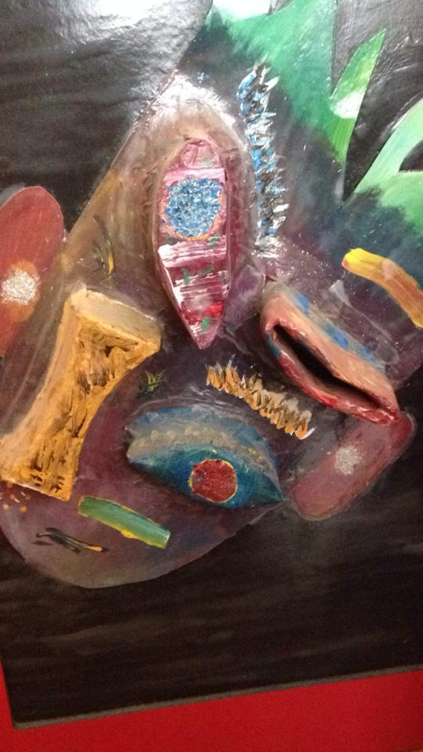

*The picture to the left demonstrates an example of what the final product could look like.*

**References:**

Board of Studies NSW. (2006). Creative Arts K-6 Syllabus. Retrieved from <http://k6.boardofstudies.nsw.edu.au/wps/wcm/connect/ce0d0525-fb53-44db-b4bb-f9d252549824/k6_creative_arts_syl.pdf?MOD=AJPERES>

Fordham, F. (2014). Visual Arts: Week 1. Retrieved from <http://leo.acu.edu.au/pluginfile.php/953876/mod_resource/content/1/WEEK1_LECTURE_FORDHAM.pdf>

The Art Story Foundation. (2014). Pablo Picasso Synopsis. Retrieved from <http://www.theartstory.org/artist-picasso-pablo.htm>